Our curriculum
Learn together, grow together is our school motto. We support all members of our school community - our staff, our families and our children—to make and keep this pledge so that our children learn, grow and thrive. Our curriculum has been developed by staff after careful reflection on the needs of our children at Springfield. Our curriculum belongs to them.
When our children start their Springfield journey, we aim to plant a special seed that we hope stays with them for life: a love of learning. We want all of our children to come to school every day excited about learning new things, confident to try new experiences and enthusiastic about facing new challenges. Woven through our curriculum are rich and engaging learning experiences which we hope become life long memories – both in the knowledge, skills and understanding our children develop, as well as the joy and sense of achievement they experienced whilst growing. By igniting their curiosity, we hope that our children will go into the world open and receptive to learning and growing throughout their life.

Springfield is a community school – it’s in our name. Our curriculum has been carefully designed to serve and reflect our diverse and vibrant community where everyone belongs and is included. Our children and families speak many languages and come from many different parts of the world. A significant number of our children have two places they call home. Through our curriculum, we embrace what unites us: that we all belong to Britain and Britain belongs to all of us. We believe our children deserve to feel a strong sense of connection to and pride in their home. Hand in hand with this, we celebrate our diversity and look beyond our borders to celebrate the different heritages and cultures which make our community so special and to broaden our children’s horizons further so they leave us knowing that there is much we share, and though we are different, we are equal.
As a rights respecting school, we value our children’s rights, as set out in the UN Convention on the Rights of the Child. This ethos is woven through our curriculum, and we seek opportunities across different subjects to explore what it means to be caring, thoughtful and respectful citizens. Our goal is that a child with Springfield roots, goes out into the world both with a sense of their rights and their responsibilities towards their community and the planet. We know it is important that our children understand the challenges that shape the modern world, and the power they have to make positive change, be it environmental, political or social.
With the love of learning firmly planted, our curriculum supports children to develop strong foundations which set them up for future success. As a school with a large proportion of children who speak English as an additional language, our curriculum is designed to ensure that our children develop into confident speakers, readers and writers, and that they read widely and develop a real love for books that lasts a lifetime. We have placed the development of language at the heart of our curriculum so that our children form strong roots from which to grow, whilst celebrating the variety of languages our children speak at home. So that each child grows firm roots in EYFS and KS1, early reading is taught expertly, with no child left behind. As children move from KS1 to KS2, reading continues to be taught with rigour, supported by our carefully-mapped reading diet and read-aloud spine. We firmly believe every child has a right to be read to, every day. This time each day is precious, prized and protected. As well as developing high standards of literacy, we want our children to leave us as confident mathematicians, with numerical fluency and flexible problem-solving strategies that help them navigate the world around them and which open doors to other areas of learning.
Whilst our children develop mastery in core subjects, our curriculum reaches far beyond those limits. Through the broad range of other subjects we teach, our children acquire far-reaching branches that help them reach out further into the world. Through our carefully-planned geography curriculum, our children enjoy opportunities to celebrate their local area and to understand its place in the world. We take our children beyond their immediate local context as they learn about the city of London and the wider study of the UK, and further afield, as they learn about what it means to be a global citizen. In history lessons, we introduce our children to the story of this island and explore threads such as invasion and settlement, technological advancement and legacy. We also explore the history of ancient civilizations so that they begin to develop a global perspective and can begin to make sense of the trials and triumphs which have shaped the world today. In subjects such as art, DT and music, we place a high emphasis both on creativity and technical skill. We want our children to have the knowledge and skills they need to appreciate works of great art, music and architecture and create, compose and construct works of their own. Our RE and PSHE lessons are important spaces for learning about difference and how to be respectful and tolerant citizens, whilst P4C lessons give our children the chance to ask questions and explore issues that may invite different viewpoints and deep thinking. In science, we build on our children’s innate curiosity and help them make sense of the world around them both through the explicit teaching and through guided experimentation and observation. We want our children to leave our classrooms with a keen eye for what makes the world such a fascinating and special place. At Springfield, we know how lucky we are to have a large and varied outdoor learning space. As our children learn and grow, we take opportunities to use our surroundings for rich learning experiences – our children learn about seasons, plants, habitats, light and so much more outside, where it is real and tangible. Where our children are immersed in experiences that take them outside their classroom we aim to ignite their curiosity and encourage their imagination.
Through each child’s journey through our curriculum, we encourage them to reach their branches further outwards. By the time they leave us, we aim for them to be prepared for the next step in their growth and ready for the broad range of subjects their secondary schools offer. We also want our children to leave us confident and positive about their futures. During their time at Springfield, we work hard to encourage our children to use their voices –in dialogue-rich lessons, on the playground with friends and to speak up to share their successes, ask for help and stand up for what they know to be right. Our children have the right to be heard and to know that their voice is valued. Our curriculum equips them with the knowledge, skills and understanding they need for success and happiness in their own future, and to play their part in having a positive impact on the world. As a community, we stand tall and proud as a whole forest of trees, with deep and far-reaching roots. We know we can learn together, grow together and make a difference.
PSHE at Springfield
Our vision
At Springfield, we value Personal, Social and Health Education (PSHE) as it supports our children in their social and emotional development as well as promoting their health and well-being. We believe that in order for our children to thrive, they need a secure understanding of how to manage their feelings and relationships and how to face challenges in their lives.

Through our PSHE curriculum, our children build the knowledge and understanding that they need to be positive citizens and to play effective role in their community. Our lessons give children an understanding of the rights and responsibilities that are part of being a good citizen, which enables them to play an active and healthy part in the life of our school, their community and the world.

We strive for our children to be informed, thoughtful and responsible individuals who are aware of their rights and responsibilities.
How we plan for and teach PSHE
We follow the Jigsaw scheme of work for PSHE, which has an integrated whole school approach. Each half term begins with a whole school assembly to introduce the theme. This is then reflected in each week’s focus value.

Each class has a weekly PSHE session to explore these themes. This subject is taught mainly with various hands on activities, discussions, debates and circle time.

Our PSHE curriculum is embedded in our whole-school ethos where we celebrate difference and values of respect, tolerance and equality.
How we evaluate learning in PSHE
The impact of our PSHE curriculum is evident in the confidence our children demonstrate when expressing their feelings and managing their friendships. Children at Springfield learn use their voice to express their emotions and to use words to solve problems. We also see the impact of this learning in our children’s engagement with their community and their care for others. The choices our children make to keep themselves safe and healthy also reflect the impact of our PSHE curriculum.

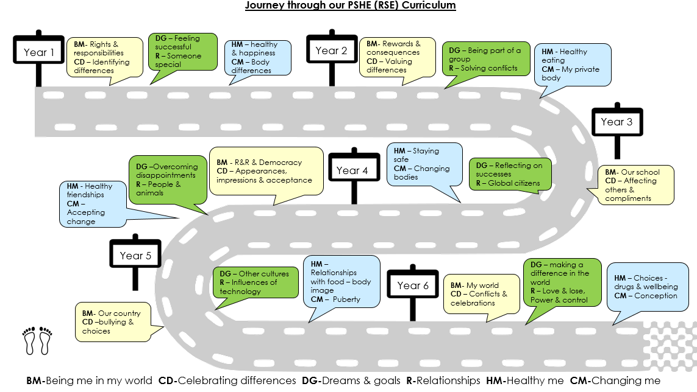

For any content written in green, more details about the learning are provided at the end of this document.
Year 1: PSHE Curriculum Map
Unit | Being Me in My World | Celebrating Difference | Dreams and Goals | Healthy Me | Relationships | Changing Me
Overview | Introduction of systems and routines for the new school year.  Establishing a class Learning Charter.  We block the teaching of this unit in the first couple of weeks at the start of term in order to establish the Learning Charter. | I can tell you some ways I am different from my friends  I understand these differences make us all special and unique | I can tell you how I felt when I succeeded in a new challenge and how I celebrated it  I know how to store the feelings of success in my internal treasure chest | I can tell you why I think my body is amazing and can identify some ways to keep it safe and healthy  I can recognise how being healthy helps me to feel happy | I can tell you why I appreciate someone who is special to me and express how I feel about them | I can identify the parts of the body that make boys different to girls and can use the correct names for these: penis, testicles, vagina  I respect my body and understand which parts are private
Details of Coverage | Feeling special and safe  Being part of a class  Rights and responsibilities  Rewards and feeling proud  Consequences  Owning the learning charter | Similarities and differences  Understanding bullying and knowing how to deal with it  Making new friends  Celebrating the differences in everyone | Setting goals  Identifying successes and achievements  Learning styles  Working well and celebrating achievement with a partner  Tackling new challenges  Identifying and overcoming obstacles  Feelings of success | Keeping myself healthy  Healthier lifestyle choices  Keeping clean  Being safe  Medicine safety/ safety with household items  Road safety  Linking health and happiness | Belonging to a family  Making friends/ being a good friend  Physical contact preferences  People who help us  Qualities as a friend and person  Self-acknowledgement  Being a good friend to myself  Celebrating special relationships | Life cycles - animal and human  Changes in me  Changes since being a baby  Differences between female and male bodies (correct terminology)  Linking growing and learning  Coping with change  Transition

For any content written in green, more details about the learning are provided at the end of this document.

Year 2: PSHE Curriculum Map
Unit | Being Me in My World | Celebrating Difference | Dreams and Goals | Healthy Me | Relationships | Changing Me
Overview | Introduction of systems and routines for the new school year.  Establishing a class Learning Charter.  We block the teaching of this unit in the first couple of weeks at the start of term in order to establish the Learning Charter. | I can identify some ways in which my friend is different from me  I can tell you why I value this difference about him/her | I can explain some of the ways I worked cooperatively in my group to create the end product  I can express how it felt to be working as part of this group | I can make some healthy snacks and explain why they are good for my body  I can express how it feels to share healthy food with my friends | I can identify some of the things that cause conflict between me and my friends  I can demonstrate how to use the positive problem solving technique to resolve conflicts with my friends | I can recognise the physical differences between boys and girls, use the correct names for parts of the body (penis, testicles, vagina) and appreciate that some parts of my body are private  I can tell you what I like/don’t like about being a boy/ girl
Details of Coverage | Hopes and fears for the year  Rights and responsibilities  Rewards and consequences  Safe and fair learning environment  Valuing contributions  Choices  Recognising feelings | Assumptions and stereotypes about gender  Understanding bullying  Standing up for self and others  Making new friends  Gender diversity  Celebrating difference and remaining friends | Achieving realistic goals  Perseverance  Learning strengths  Learning with others  Group cooperation  Contributing to and sharing success | Motivation  Healthier choices  Relaxation  Healthy eating and nutrition  Healthier snacks and sharing food | Different types of family  Physical contact boundaries  Friendship and conflict  Secrets  Trust and appreciation  Expressing appreciation for special relationships | Life cycles in nature  Growing from young to old  Increasing independence  Differences between female and male bodies (correct terminology)  Assertiveness  Preparing for transition

For any content written in green, more details about the learning are provided at the end of this document.

Year 3: PSHE Curriculum Map
Unit | Being Me in My World | Celebrating Difference | Dreams and Goals | Healthy Me | Relationships | Changing Me
Overview | Introduction of systems and routines for the new school year.  Establishing a class Learning Charter.  We block the teaching of this unit in the first couple of weeks at the start of term in order to establish the Learning Charter. | I can tell you about a time when my words affected someone’s feelings and what the consequences were  I can give and receive compliments and know how this feels | I can evaluate my own learning process and identify how it can be better next time  I am confident in sharing my success with others and know how to store my feelings of success in my internal treasure chest | I can identify things, people and places that I need to keep safe from, and can tell you some strategies for keeping myself safe including who to go to for help  I can express how being anxious or scared feels | I can explain how some of the actions and work of people around the world help and influence my life and can show an awareness of how this could affect my choices | I can identify how boys’ and girls’ bodies change on the inside during the growing up process and can tell you why these changes are necessary so that their bodies can make babies when they grow up I recognise how  I feel about these changes happening to me and know how to cope with these feelings
Details of Coverage | Setting personal goals  Self-identity and worth  Positivity in challenges  Rules, rights and responsibilities  Rewards and consequences  Responsible choices  Seeing things from others’ perspectives | Families and their differences  Family conflict and how to manage it (child-centred)  Witnessing bullying and how to solve it  Recognising how words can be hurtful  Giving and receiving compliments | Difficult challenges and achieving success  Dreams and ambitions  New challenges  Motivation and enthusiasm  Recognising and trying to overcome obstacles  Evaluating learning processes  Managing feelings  Simple budgeting | Exercise  Fitness challenges  Food labelling and healthy swaps  Attitudes towards drugs  Keeping safe and why it’s important online and offline scenarios  Respect for myself and others  Healthy and safe choices | Family roles and responsibilities  Friendship and negotiation  Keeping safe online and who to go to for help  Being a global citizen  Being aware of how my choices affect others  Awareness of how other children have different lives  Expressing appreciation for family and friends | How babies grow  Understanding a baby’s needs  Outside body changes  Emotional changes - we have added this lesson in so children understand some emotional changes that happen in puberty  Family stereotypes  Challenging my ideas  Preparing for transition  We have moved the ‘Inside body changes’ lesson to Y5 Summer 2.

For any content written in green, more details about the learning are provided at the end of this document.

Year 4: PSHE Curriculum Map
Unit | Being Me in My World | Celebrating Difference | Dreams and Goals | Healthy Me | Relationships | Changing Me
Overview | Introduction of systems and routines for the new school year.  Establishing a class Learning Charter.  We block the teaching of this unit in the first couple of weeks at the start of term in order to establish the Learning Charter. | I can tell you a time when my first impression of someone changed as I got to know them  I can explain why it is good to accept people for who they are | I know how to make a new plan and set new goals even if I have been disappointed I know what it means to be resilient and to have a positive attitude | I can recognise when people are putting me under pressure and can explain ways to resist this when I want to  I can identify feelings of anxiety and fear associated with peer pressure | I can explain different points of view on an animal rights issue and express my own opinion and feelings on this | I can identify what I am looking forward to when I am in Year 5  I can reflect on the changes I would like to make when I am in Year 5 and can describe how to go about this
Details of Coverage | Being part of a class team  Being a school citizen  Rights, responsibilities and democracy (school council)  Rewards and consequences  Group decision-making  Having a voice  What motivates behaviour | Challenging assumptions  Judging by appearance  Accepting self and others  Understanding influences  Understanding bullying  Problem-solving  Identifying how special and unique everyone is  First impressions | Hopes and dreams  Overcoming disappointment  Creating new, realistic dreams  Achieving goals  Working in a group  Celebrating contributions  Resilience  Positive attitudes | Healthier friendships  Group dynamics  Smoking  Alcohol  Assertiveness  Peer pressure  Celebrating inner strength | Jealousy  Love and loss  Memories of loved ones  Getting on and falling out  Showing appreciation to people and animals  We have moved the ‘Girlfriends and boyfriends’’ lesson to Y6 Summer 2. | Being unique  Girls and puberty*  Confidence in change  Accepting change  Preparing for transition  Environmental change  We have moved the ‘Having a baby’’ lesson to Y6 Summer 2.

For any content written in green, more details about the learning are provided at the end of this document.

Year 5: PSHE Curriculum Map
Unit | Being Me in My World | Celebrating Difference | Dreams and Goals | Healthy Me | Relationships | Changing Me
Overview | Introduction of systems and routines for the new school year.  Establishing a class Learning Charter.  We block the teaching of this unit in the first couple of weeks at the start of term in order to establish the Learning Charter. | I can explain the differences between direct and indirect types of bullying I know some ways to encourage children who use bullying behaviours to make other choices and know how to support children who are being bullied | I can describe the dreams and goals of a young person in a culture different from mine and can reflect on how these relate to my own | I can describe the different roles food can play in people’s lives and can explain how people can develop eating problems (disorders) relating to body image pressures I respect and value my body | I can explain how to stay safe when using technology to communicate with my friends  I can recognise and resist pressures to use technology in ways that may be risky or cause harm to myself or others | I can describe how boys’ and girls’ bodies change during puberty  I can express how I feel about the changes that will happen to me during puberty
Details of Coverage | Planning the forthcoming year  Being a citizen  Rights and responsibilities  Rewards and consequences  How behaviour affects groups  Democracy, having a voice, participating | Cultural differences and how they can cause conflict  Racism  Rumours and name-calling  Types of bullying  Material wealth and happiness  Enjoying and respecting other cultures | Future dreams  The importance of money  Jobs and careers  Dream jobs and how to get there  Goals in different cultures  Supporting others (charity) | Smoking, including vaping  Alcohol  Alcohol and anti-social behaviour  Emergency aid  Body image  Relationships with food  Healthy choices  Motivation and behaviour | Self-recognition and self-worth  Building self-esteem  Safer online communication  Rights and responsibilities online  Online gaming and gambling  Reducing screen time  Dangers of online grooming  SMART internet safety rules | Self and body image  Influence of online and media on body image  Puberty for girls  Puberty for boys  Growing responsibility  Coping with change  Preparing for transition  We have moved ‘Conception (including IVF)’ to Y6 Summer 2. As part of the statutory science National Curriculum, Y5 children will learn about scientific reproduction in mammals.

For any content written in green, more details about the learning are provided at the end of this document.

Year 6: PSHE Curriculum Map
Unit | Being Me in My World | Celebrating Difference | Dreams and Goals | Healthy Me | Relationships | Changing Me
Overview | Introduction of systems and routines for the new school year.  Establishing a class Learning Charter.  We block the teaching of this unit in the first couple of weeks at the start of term in order to establish the Learning Charter. | I can explain ways in which difference can be a source of conflict or a cause for celebration and can show empathy with people in either situation | I can describe some ways in which I can work with other people to help make the world a better place  I can identify why I am motivated to do this | I can evaluate when alcohol is being used responsibly, antisocially or being misused  I can tell you how I feel about using alcohol when I am older and my reasons for this | I can recognise when people are trying to gain power or control  I can demonstrate ways I could stand up for myself and my friends in situations where others are trying to gain power or control | I can describe how a baby develops from conception through the nine months of pregnancy, and how it is born and  I recognise how I feel when I reflect on the development and birth of a baby
Details of Coverage | Identifying goals for the year  Global citizenship  Children’s universal rights  Feeling welcome and valued  Choices, consequences and rewards  Group dynamics  Democracy, having a voice  Anti-social behaviour  Role-modelling | Perceptions of normality  Understanding difference  Power struggles  Understanding bullying  Inclusion/ exclusion  Differences as conflict/ differences as celebration  Empathy | Personal learning goals, in and out of school  Success criteria  Emotions in success  Making a difference the world  Motivation  Recognising achievements  Compliments | Taking personal responsibility  How substances affect the body  Exploitation, including ‘county lines’ and gang culture  Emotional and mental health  Managing stress | Mental health  Identifying mental health worries and sources of support  Love and loss  Managing feelings  Power and control  Assertiveness  Technology safety  Take responsibility with technology use | Self-image  Body image  Puberty and feelings*  Conception to birth**  Physical attraction (boyfriends/ girlfriends)/ Respect and consent/ Sexting  Reflections about change  Transition*Teachers will use the Y5 ‘Puberty for girls’ and ‘Puberty for boys’ lessons, alongside some of the Y6 puberty myth buster cards.  **Parents and carers have the right to withdraw their child from the ‘Conception to birth’ - combination of the Y4 and Y5 lessons that we moved and the Y6 lesson.

Year | Unit | Term | Potential Question | What We’re Teaching | Resources
1 | Healthy Me - Medicine safety/ safety with household items | Sp2 | Why are we teaching children about safety around medicine? | We explain why we have medicine and how adults and children might have different medicine because our bodies are different; we explain how to be safe with medicine, as well as how to be safe around household items. | 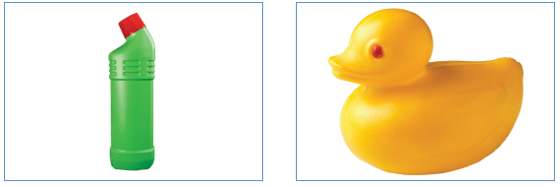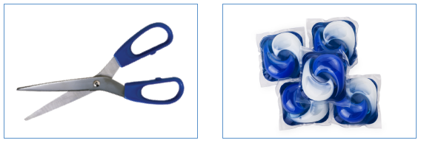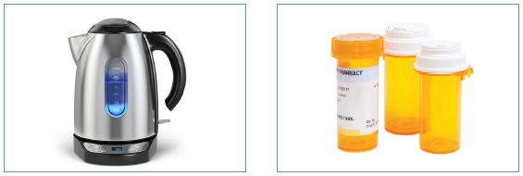
1 | Relationships - Belonging to a family | Su1 | How are we showing families look different? | We discuss and compare who is in our family - will show a book with images of all types of families including where single parents, couples, grandparents, same sex parents, uncles/aunts etc. raise the family to show that all families look different. We do this so that children see images of how the world looks. | The Great Big Book of Families - highlights similarities and differences around what a family looks like; homes; jobs; hobbies etc.
1 | Relationships - Physical contact boundaries | Su1 | Which images do we use to show physical contact? | We talk about which physical contact we like and which physical contact we don’t like e.g. how some people like holding hands and how some don’t. We show pictures to demonstrate how and when people might want to hold hands. We ensure the pictures we use are as inclusive and representative as possible. | 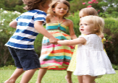  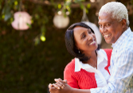  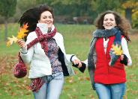  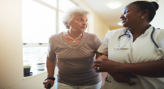  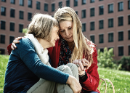
1 | Changing Me - Life cycles - animal and human | Su2 | How are we showing life cycles, particularly in humans? | First, we have children match the young to the adults - in both animals and humans - then we show a few stages e.g. caterpillar, chrysalis, butterfly; baby in the womb, toddler, adult - all done using cartoon pictures, although we may sometimes use well-chosen photos from the internet for things like puppies, toddlers, adults etc. | 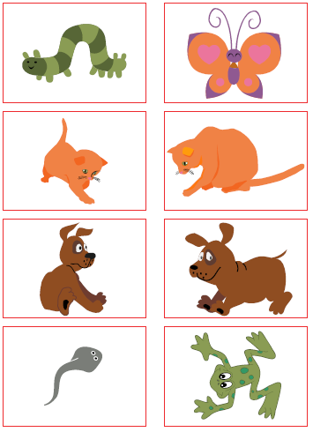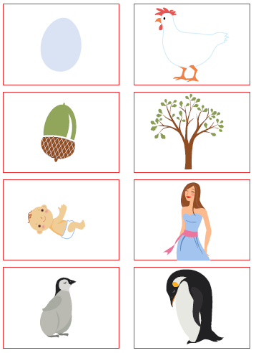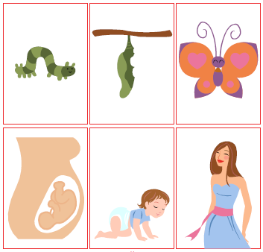
1 | Changing Me - Changes in me | Su2 | Which changes are we showing the children? | We promote discussions around how people change from when their babies - we show photos and cartoons of people as babies, toddlers, teens, adults etc. We talk about how changes can be physical, like getting taller, growing a beard, as well as how we change in other ways e.g. we learn, we start to walk etc. | 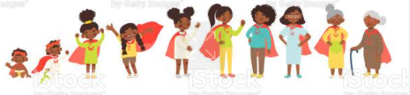
1 | Changing Me - Differences between female and male bodies (correct terminology) | Su2 | How are we showing differences between female and male bodies? Which terminology are we teaching? | We show how females and males are different both through what they sometimes wear and through their bodies. We also show how animals look different depending whether they’re female or male.  We teach children to use the correct terminology for their body parts for safeguarding reasons e.g. if they have a pain in a part of their body, they need to know how to describe where the pain is. The terminology we use are: penis, testicles, vagina, vulva, anus. Many organisations believe knowing shared, correct terminology keeps children safe too. We always use cartoons to show the terminology, which builds upon what the children learn in EYFS (nose, leg, knee etc.) Children then use the pictures to organise whether a female, male or both would have those body parts.  Children are still taught that these parts are private and that they might use different names; however, these are the scientific words that we use in school. | 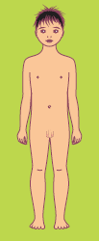  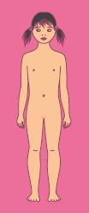  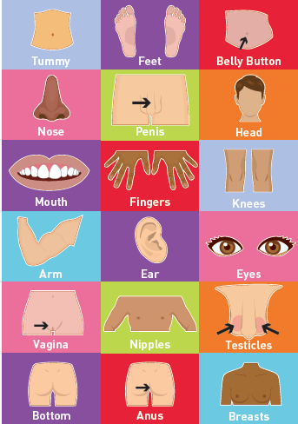  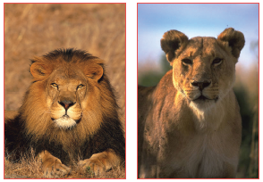

Year |  | Unit |  | Term |  | Potential Question |  | What We’re Teaching | Resources
2 | Celebrating Differences - Gender diversity |  | A2 |  | What are we teaching children about gender diversity? |  | We question how you might know someone is a boy or a girl, which brings children onto the topic of the clothes people choose to wear and the idea of stereotyping someone for what they wear or the things that they like to do, like playing football.  We teach children that everyone is treated equally and fairly, regardless of whether they are male or female. We teach them that they should always treat each other kindly. |  |  | 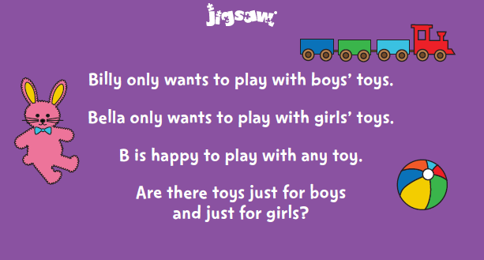  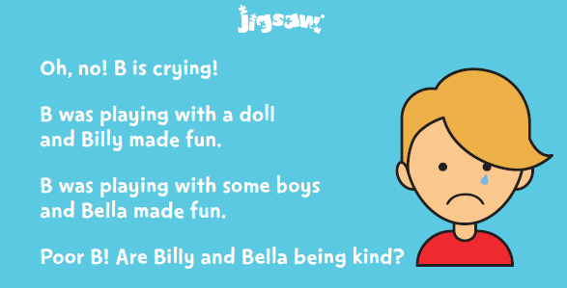
2 | Relationships - Different types of family |  | Su1 |  | What do we teach when we talk about different types of family? |  | We discuss and compare who is in our family - will show a book with images of all types of families including where single parents, couples, grandparents, same sex parents, uncles/aunts etc. raise the family to show that all families look different.  We focus on how even if our families look different, they are special to us because they are rooted in love and because no one has the same family so they are unique. |  |  | The Great Big Book of Families - highlights similarities and differences around what a family looks like; homes; jobs; hobbies etc.  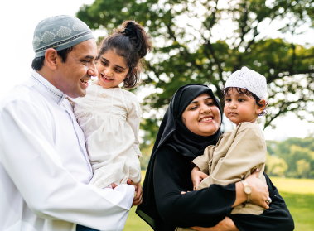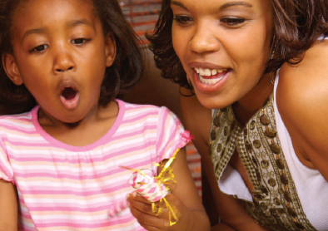  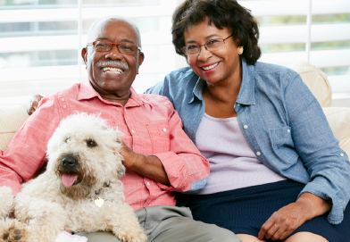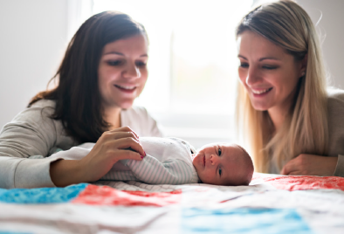
2 | Relationships - Physical contact boundaries |  | Su1 |  | What are we teaching about physical contact? |  | We discuss with children contact that they like and contact they don’t like, as well as which contact is acceptable in different situations. Some examples would be a wet kiss from a dog, being tickled, play-fighting with friends, holding hands when crossing the road or in a crowded space, pushing or hitting, hugs from people not in the family etc. We teach children that sometimes people like some of these things and sometimes they don’t so they have a right to say, “Please stop, I don’t like that.” We teach children how to use kind hands. |  |  | 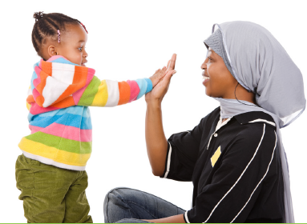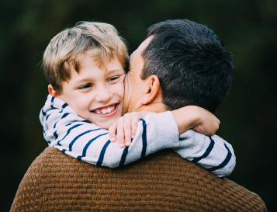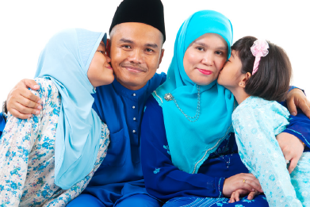
2 | Relationships - Secrets |  | Su1 |  | What are we teaching children about secrets? |  | We teach the children how there are different types of secrets e.g. an exciting one like a surprise birthday party vs. a worrying one, where someone has asked you to keep a secret and it makes you feel worried/ have a bad feeling in your stomach. We teach the children this so that they speak to a trusted adult if they ever feel uncomfortable about something so that they are safe. |  |  | 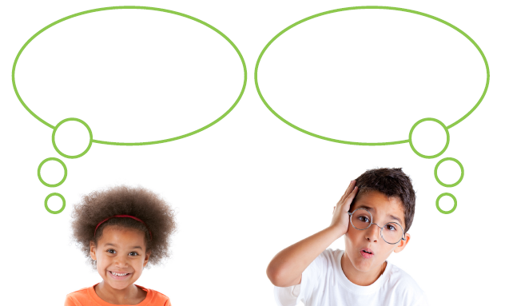
2 | Changing Me - Life cycles in nature |  | Su2 |  | How do we show the life cycles? |  | Building upon what is learnt in Y1, we show children cartoons and photos of how humans, animals and plants look when they’re young and when they’re adults. We discuss how things change and the feelings that go along with change e.g. fear, excitement, nerves etc. |  |  | 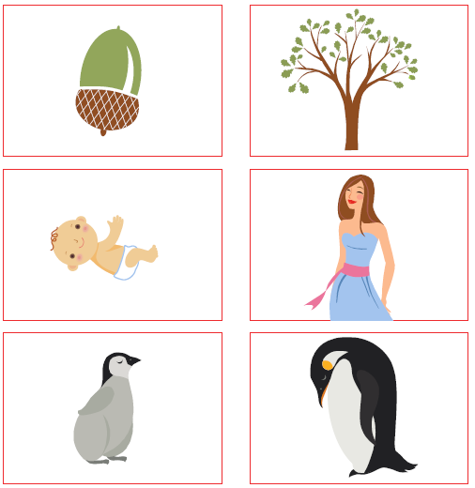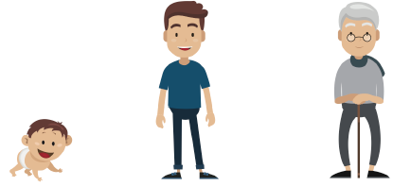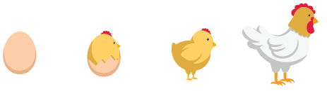
2 | Changing Me - Differences between female and male bodies (correct terminology) |  | Su2 |  | How are we showing differences between female and male bodies? Which terminology are we teaching? |  | This follows on from what the children are taught in Y1. We show how females and males are different both through what they sometimes wear and through their bodies.  We teach children to use the correct terminology for their body parts for safeguarding reasons e.g. if they have a pain in a part of their body, they need to know how to describe where the pain is. The terminology we use are: penis, testicles, vagina, vulva, anus. Many organisations believe knowing shared, correct terminology keeps children safe too. We always use cartoons to show the terminology, which builds upon what the children learn in EYFS (nose, leg, knee etc.)  Children are still taught that these parts are private and that they might use different names; however, these are the scientific words that we use in school.  The teacher draws an outline of two bodies - a male body and a female body - and the children need to move the images to the correct places on the body.  Children are also shown a laundry bag/ images of different clothes, where they need to decide if they think the clothes belong to a male or female - they discuss the reason for different clothes - to keep us warm, for fashion, to keep certain body parts private.

Year | Unit | Term | Potential Question | What We’re Teaching | Resources
3 | Celebrating Differences - Families and their differences | A2 | How are we showing that families can be different? | We discuss and compare who is in our family - will show images of all types of families including where single parents, couples, grandparents, same sex parents, uncles/aunts etc. raise the family to show that all families look different. We also discuss how some families have couples who are married, some have other members of their family living in a different country, some who are helped by other members of the community etc. We do this so that children see images of how the world looks. We might also choose to read a book that also outlines these similarities and differences. | 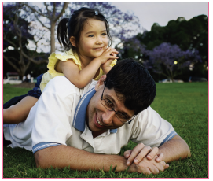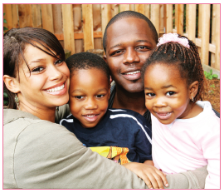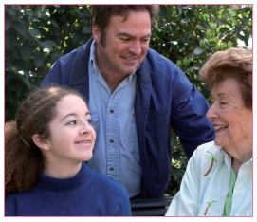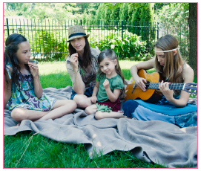  The Great Big Book of Families - highlights similarities and differences around what a family looks like; homes; jobs; hobbies etc.
3 | Celebrating Differences - Witnessing bullying and how to solve it/ Recognising how words can be hurtful | A2 | Which types of bullying do we teach the children about? | We teach the children about all forms of bullying from physical, emotional, mental and cyber bullying. This is because we want the children to understand how their words and behaviours can affect others and what to do if they see these things happening. We discuss things like ableism and homophobia and how to ensure our actions and words don’t hurt others.
3 | Healthy Me - Attitudes towards drugs | Sp2 | What are we teaching the children about drugs? | We speak with the children about how medicines and drugs all look different (we will show pictures) and have different usages e.g. how some medicines are prescribed or given by a trusted adult to make a part of our body feel better. We discuss how we know when it is safe or unsafe to take a drug or medicine and what to do if they encounter drugs or medicines.
3 | Changing Me - How babies grow | Su2 | How do we explain that babies grow? | We discuss how a baby grows inside a mother’s womb and gets nutrients when it’s in the womb, in order to grow. We don’t discuss how the baby gets in the mother’s womb but if asked, explain in an age-appropriate way, which is that a baby grows from a tiny egg that the mother already has inside her. We show images so children can see how the nutrients help the baby to grow. | 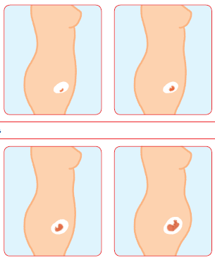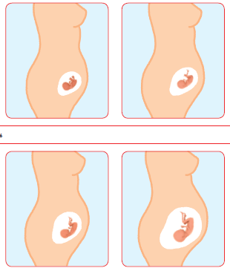
3 | Changing Me - Outside body changes | Su2 | Which external changes are the children learning about? | We speak to the children about changes and how puberty is one of the changes people go through and how it is the start of when a child’s body gradually develops into an adult’s body. We explain that it is natural and can happen at any age, either when we’re in primary school or in secondary school. We explain that everyone grows and develops at a different rate to one another.  Using appropriate vocabulary that the children learn in KS1, we show children age-appropriate cartoons and have them discuss which physical, external changes they can see and then talk about other physical changes that you can’t always see e.g. how our voices deepen. | 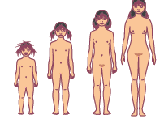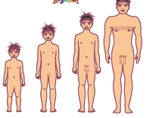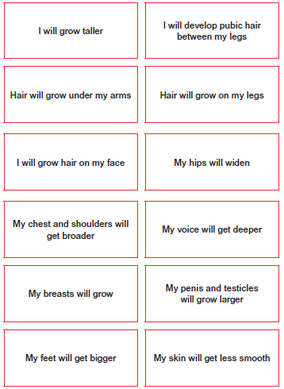
3 | Changing Me - Inside body changes  This lesson has been moved to Y4 Summer 2.  This is now called ‘Emotional changes’ in Y3 | Su2 | Which internal changes are the children learning about? | We will teach children in Y3 about emotional changes that come along with puberty instead of inside body changes.

Year | Unit | Term | Potential Question | What We’re Teaching | Resources
4 | Healthy Me - Smoking | Sp2 | What are we teaching about smoking? | We discuss with the children the idea of peer pressure in regards to smoking, linking to the previous lesson of how different people have different roles in groups and, often, encourage others to make poor decisions. We talk about how peer dynamics might impact these choices. We also talk to them about the impact that smoking has on our health and the health of others. We explain that there is an age limit to purchase cigarettes because it has an impact on our health.
4 | Healthy Me - Alcohol | Sp2 | What are we teaching about alcohol | Similarly to the previous lesson on smoking, we talk to the children about alcohol, discussing why people might drink alcohol and how it could alter people’s behaviour if drunk in excess. We speak about the role of the liver and how alcohol impacts it. We also link this to peer pressure. We explain that there is an age limit because consuming alcohol has an impact on our health.
4 | Relationships - Love and loss | Su1 | What do we teach children about loss? | Particularly at this time, it is more important than ever to talk to children about loss and the strategies to support if we’ve experienced loss. Like all lessons, this is discussed sensitively. We read a story and explain how sometimes we might lose special people, pets etc. because we move or someone close to us passes away. We explain that the reason loss is so hard is because we value and love those people. We think about things that we can do and people we can talk to if we feel sad, angry, unsure or insecure. | Some books we might choose to read are:  Badger’s Parting Gifts  Goodbye Mousie
4 | Relationships - Girlfriends and Boyfriends  This has been moved to Y6 Summer 2. | Su1 | What do we teach about boyfriends and girlfriends?
4 | Changing Me - Having a Baby  This has been moved to Y6 Summer 2. | Su2 | What are we teaching the children about having a baby?
4 | Changing Me - Girls and Puberty  This is a combination of the Y3 ‘Inside body changes’ and the Y4 ‘Girls and puberty’ lessons. | Su2 | What are we teaching about puberty in girls? | It is believed that girls should be taught about menstruation and bodily changes before they go through them. This is so they feel prepared physically and emotionally for the changes that they will experience. We know that some females will go through puberty earlier than others, just like we know some will go through it later in their teens. However, we, like many, believe the importance of preparing them in advance.  In the lesson, we share a bag of objects with the children, which has deodorant, spot cream, gel, tampons, sanitary towels etc. and have the children think about what the objects are, stressing that many people won’t know what they are because they haven’t needed to use them. We reveal each of the objects and move onto the topic of menstruation - some children aren’t aware that this means the same as having your period so we make this clear. We explain that when a female reaches puberty, the eggs in her ovaries (which have been there since she was born) start to mature. Then, once a month, these eggs that are stored in the ovaries are released and go through the fallopian tube into the womb/uterus. If the egg is fertilised, it settles into the lining of the womb/uterus and develops into a baby. If it isn’t, the lining of the womb/uterus sheds and spare blood is passed, which is when she has her period. This is normal for females and the amount of blood that is released varies for different people. As females bleed, they need something to absorb the blood, which is why they use sanitary towels, which stick onto the inside of the underwear, or tampons, which are inserted into the vagina. It is important that these are changed regularly. | 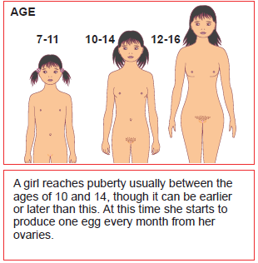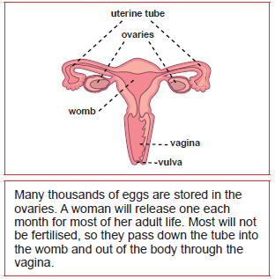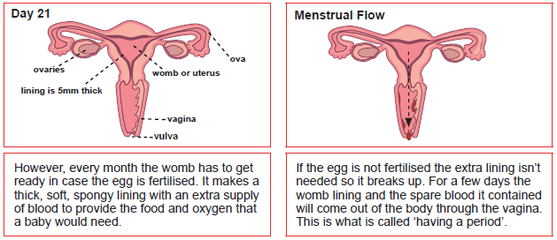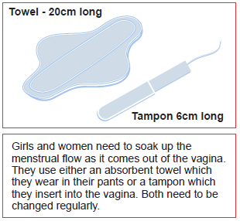

Year | Unit | Term | Potential Question | What We’re Teaching | Resources
5 | Healthy Me - Smoking | Sp2 | What are we teaching the children about smoking? | Building on from what is taught in the previous year, we speak to the children about the effects of smoking and the impact it has on our health. We talk about how smoking is portrayed in films, TV and celebrity culture and have them think about messages that are promoted. We discuss how people often lead others to thinking that smoking is fashionable, which then leads to the discussion of peer pressure. The reason we teach this is so that children recognise how certain avenues might try to put pressure on people to smoke so we want to empower them to recognise this and to understand the realities of smoking.
5 | Healthy Me - Alcohol | Sp2 | What are we teaching the children about alcohol? | Building on from what is taught in the previous year, we share facts about alcohol and discuss how it can lead to anti-social behaviour. We talk about how alcohol can influence people’s behaviour when misused and have them think of scenarios that would be different if people choose - we provide one story and they think about how it could be different. We think about peer pressure when looking at different scenarios. | 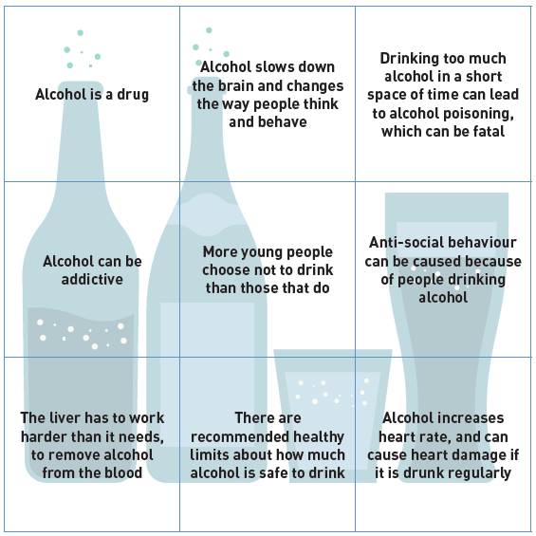
5 | Healthy Me - Emergency Aid | Sp2 | Which emergency aid do we cover? | We discuss with the children different emergencies they may come across from someone cutting a finger to someone collapsing. We talk to the children about what to do in these situations and explain what the recovery position is, using St John’s Ambulance videos. | https://www.youtube.com/watch?v=GmqXqwSV3bo&t=6s  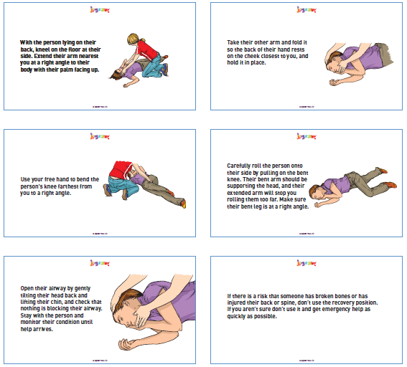
5 | Healthy Me - Relationships With Food | Sp2 | What do we talk to the children about in terms of their relationships with food? | We speak about how different people can often have different relationships with food and that sometimes, for various reasons such as pressure, things that are seen on TV/ the internet, or perceptions of body image, people can sometimes have an unhealthy relationship with food. We ask the children to think about what a healthy body image means, talking about a balanced diet, physical exercise, resilience, knowing if someone is influencing or pressuring us etc. This is so that they know what a positive relationship with food and their image looks like. | 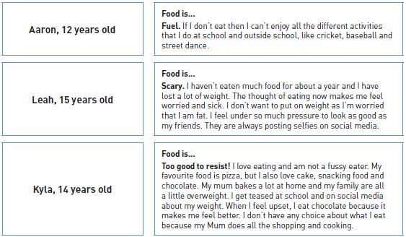
5 | Relationships - Online Gaming | Su1 | What type of gaming do we talk to the children about? | In addition to Online Safety lessons that are taught in Computing, we speak to the children about risks that are attached to online gaming. We discuss all of the positives that come from gaming but acknowledge that there are also negatives/ risks. We discuss how often, children have to say that they are a certain age to play a game and that because they just tick it, they can sometimes expose themselves to risk. We discuss scenarios where there could be inappropriate content or where people could talk to them, if the app or game is not suitable for children their age. We discuss additional risks that also come with other games that are suitable for children their age e.g. if they are talking to strangers on something like Roblox and how some people lie about who they are because they sometimes want to harm people. Due to this, we equip them with skills on what to do to stay safe (ask a trusted adult if they’re allowed to talk to people; don’t ever give out personal details; tell a trusted adult if something doesn’t feel right). We follow up this lesson in the final lesson of this unit, where we discuss how to stay safe when communicating online.
5 | Changing Me - Puberty in Girls | Su2 | What are we teaching about puberty for girls? | It is believed that girls should be taught about menstruation and bodily changes before they go through them. This is so they feel prepared physically and emotionally for the changes that they will experience. We know that some females will go through puberty earlier than others, just like we know some will go through it later in their teens. However, we, like many, believe the importance of preparing them in advance. This is why we want them to learn about puberty for girls in year 4 but to continue this in year 5, if girls go through puberty in that year or soon after. In the lesson, we talk about what makes us sometimes feel embarrassed and what we can do to try to cope with any embarrassment. We explain that sometimes we get embarrassed as we grow up because our bodies start to change but this is something we will all eventually go through and it is normal.  We discuss how females and males go through puberty because it means their bodies are developing so that one day, they might be able to create a baby. We briefly explain where the sperm is stored and where the ovaries are stored and how this is linked to puberty. We then show diagrams of how the sperm will fertilise the egg, which will create a baby. We talk about this because it explains why everyone goes through puberty.  We talk about how one change in females is called menstruation - some children aren’t aware that this means the same as having your period so we make this clear. We explain that when a female reaches puberty, the eggs in her ovaries (which have been there since she was born) start to mature. Then, once a month, these eggs that are stored in the ovaries are released and go through the fallopian tube into the womb/uterus. If the egg is fertilised, it settles into the lining of the womb/uterus and develops into a baby. If it isn’t, the lining of the womb/uterus sheds and spare blood is passed, which is when she has her period. This is normal for females and the amount of blood that is released varies for different people. As females bleed, they need something to absorb the blood, which is why they use sanitary towels, which stick onto the inside of the underwear, or tampons, which are inserted into the vagina. It is important that these are changed regularly. We show the children tampons with and without the applicators and sanitary towels with and without the wings so that they understand that sanitary products can often look different. We explain how they are used so that they feel equipped if and when they need to use them. | 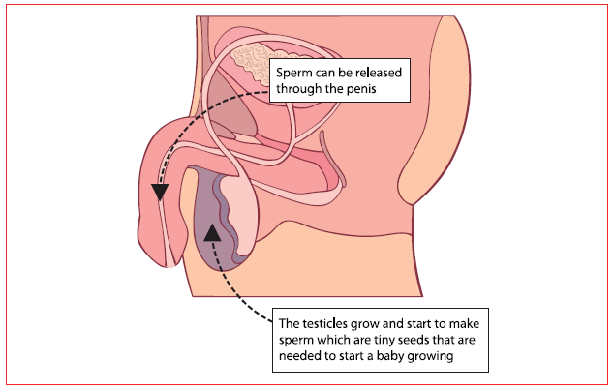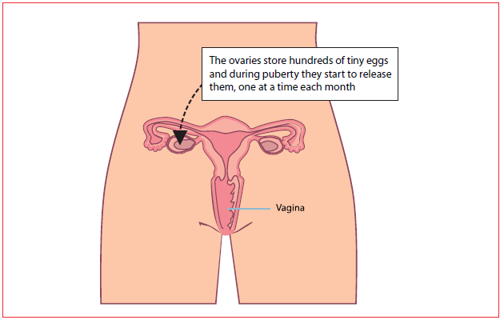  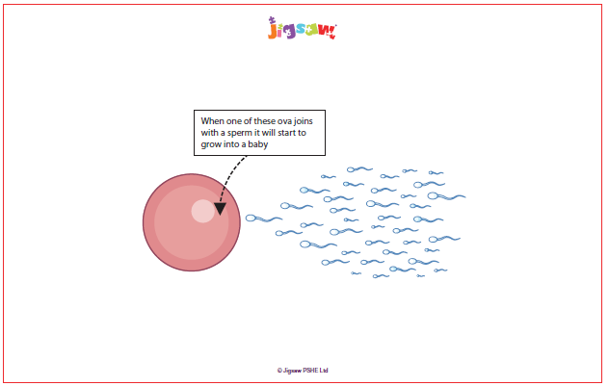  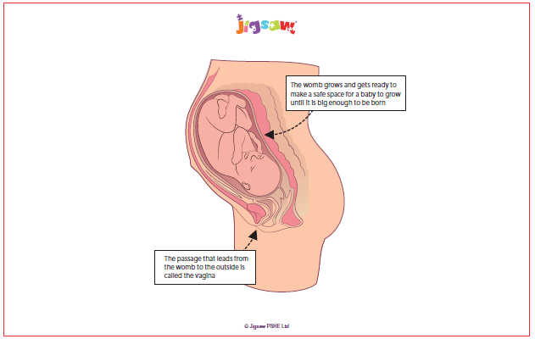  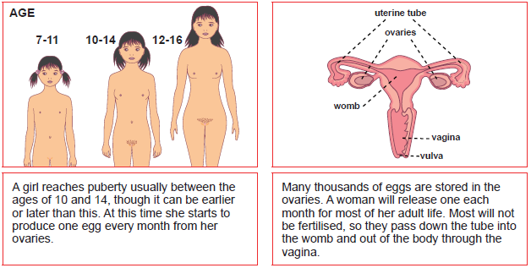  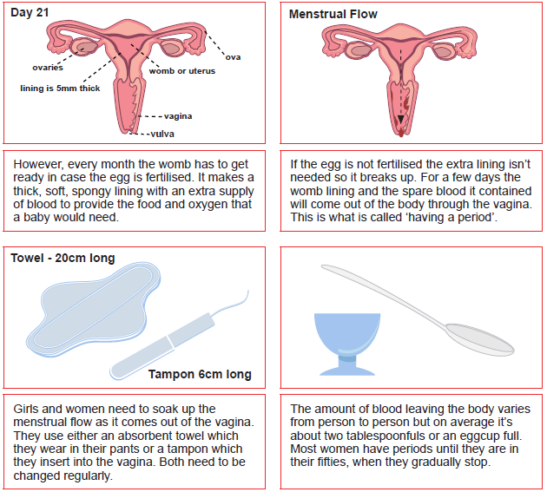
5 | Changing Me - Puberty in Boys | Su2 | What are we teaching about puberty for boys? | Continuing on from the previous lesson about puberty in girls, we explain the changes that boys’ bodies go through to prepare them to one day be able to have children, if they choose. We discuss how there are many similarities and differences between puberty in males and females and between different males too. We use diagrams to explain how when a male reaches puberty, his testicles start to make more of a hormone called testosterone, which is responsible for the physical and emotional changes males go through in puberty. Around this time, the male’s testicles will start to get bigger, they might develop facial hair or hair in other places around the body, the shape of their body might change, their voice might get deeper but it is different for every male. We explain how in the testes, there are many tubes, which create sperm, which swims in a liquid called semen and carries genes. It may one day fertilise a female’s eggs to create a baby. We explain how when a male becomes excited, blood rushes to his penis and it becomes erect and that this is normal. We need males to understand that it happens and they shouldn’t be embarrassed by it. Sometimes, it might happen when they least expect it, for example when they’re asleep, some semen might come out and this is normal. We use vocabulary such as sperm, semen, testicles, testes, erection, ejaculation, wet dream and larynx.  We need to explain all of these things to the males we teach because we need them to know that these are normal bodily changes, just as we speak to females about menstruation.  We then discuss any concerns the males or females in the class have around puberty.
5 | Changing Me – Conception  This has been moved to Y6 Summer 2. | Su2 | What are we teaching the children about conception?

Year |  | Unit |  | Term |  | Potential Question |  | What We’re Teaching | Resources
6 | Celebrating Difference - Understanding difference |  | A2 |  | Which differences are we teaching the children? |  | This lesson teaches the children about accepting people for who they are. The lesson looks at people’s perceptions towards gender and someone’s choice to change their gender when they become an adult and the impact people’s responses had on their life. We teach children how all people should be treated equally and with respect, as our school’s teachings are rooted in kindness and love.
6 | Healthy Me - Taking personal responsibility |  | Sp2 |  | What are some things we teach children about taking personal responsibility for their health? |  | In addition to speaking to the children about what they do to look after themselves e.g. making a packed lunch, having a shower, exercising, we also talk to the children about immunisations and vaccines. We explain how vaccinations help our immune systems and that many, but not all, people choose to have their babies vaccinated. However, some people choose not to because of their beliefs or fearing there will be side-effects. We explain how many people, not just babies, need vaccinations when they go abroad or for other reasons. We link this lesson to the development of COVID-19 vaccines.
6 | Healthy Me - How substances affect the body |  | Sp2 |  | Which substances do we teach the children about? |  | Like in previous years, we teach the children about a variety of drugs, both in terms of ones that help you and others that have negative consequences. We speak to them about unrestricted drugs e.g. caffeine; restricted ones e.g. tobacco or alcohol; prescribes drugs like insulin, steroids, asthma medication, anti-allergy medicines; and illegal drugs like cannabis. We speak to them about the effects that different drugs have on different people, particularly with illegal drugs and how they can often contain dangerous chemicals that people are unaware of. This in turn can impact vital organs. We talk to the children about how even legal or prescription drugs can also affect the body e.g. how caffeine can increase the heart rate, and should therefore be used in moderation/ following the prescription dosage. We finally discuss why people might choose to buy or sell drugs and how drug misuse can lead to addiction.
6 | Healthy Me - Exploitation, including ‘county lines’ and gang culture |  | Sp2 |  | What do we teach the children about exploitation? |  | Note: where possible, we aim to supplement this lesson with a session with the police or Young Hackney, particularly around exploitation and gangs. We discuss with children what a gang is and reasons why people might become involved in a gang. We discuss how some gangs operate and why they often exploit or target certain people, particularly more vulnerable people. A big part of the lesson is having the children look at different scenario cards and thinking why the people in them, who are from all different backgrounds, might become involved in a gang.
6 | Healthy Me - Emotional and mental health |  | Sp2 |  | What are we teaching the children about mental health? |  | Straight away, we explain to the children that everyone has mental health, just like they have physical health. Just as we try to keep our bodies healthy, we need to do the same for our minds. This is why we sometimes use the word well-being rather than health. We think about how many people we know who have a physical illness, or who may sometimes become physically ill, and explain that this happens with mental illness too. We discuss how when we feel low, sad, angry or worried, it can often take a toll on our mental well-being so we discuss strategies of what we can do if we start to feel like this, just as we would do with our physical well-being. We share strategies that might help ourselves and others e.g. being with people who make us happy, exercising, drinking water, listening to music, being on our own for a little bit, reading etc. We also talk about the importance of speaking to a trusted adult if we ever feel overwhelmed by our emotions.
6 | Healthy Me - Managing stress |  | Sp2 |  | Why do our children need to know about managing stress? |  | The idea of going into secondary school or completing exams can often make some children feel quite stressed so we look at ways that they can calm themselves, using techniques similar to those we discuss in the previous lesson about well-being. As this unit also teaches the children about substance misuse, we speak to the children about how some people might misuse substances if they feel stressed or under a lot of pressure and the effects that this can have on those people and the people around them. We end focusing on the strategies we could use if we feel stressed.
6 | Relationships - Mental health |  | Su1 |  | What are we teaching the children about mental health? |  | We speak to the children in the previous unit about looking after their emotional and mental health and this lesson builds upon that, looking at stigma that is often attached to the term ‘mental health’. We discuss how just like with our physical health, we aim for there to be a balance - in terms of challenges and ways to get support - for our mental health too and that it is normal if we aren’t always ‘balanced’ because we will always face challenges that might make us feel certain extremes. We discuss how some people with mental health problems feel they need to hide them; how sometimes, people who have them are treated unfairly; and how we can’t always see if someone has mental health problems. We signpost people the children can talk to if they need to, particularly their trusted adult if they need support.
6 | Relationships - Identifying mental health worries and sources of support |  | Su1 |  | What are we teaching the children about mental health? |  | Building upon the previous lesson, here, we discuss where to seek support if we feel we need it. We continue to talk about how challenges are a part of life and how everyone at some point might struggle so we all need to be able to spot when we might need support by thinking about how we’re feeling and having regular ‘check ins’ with ourselves. We discuss how sometimes stress and anxiety can be too much for some people, which is when they might misuse things or try to hurt themselves but we stress the importance of noticing if someone might not be themselves or if we don’t feel quite right so that we can get support if we need it.
6 | Relationships - Technology safety |  | Su1 |  | Which online harms are we teaching the children about? |  | Throughout the year, children regularly have online safety lessons, looking at the risks and rewards of being online. In this lesson, we get the children to think about how many new websites are created every hour (34,260), highlighting how the internet is ever expanding and how some of them may not be what they seem or may not be as safe as they look. We have them think about how they would judge if something were true or not and point them to the SMART rules, which look at not sharing private information, never meeting up with people they don’t know, only accepting messages and emails from people they know, deciding which websites are reliable, rights and responsibilities online and talking to a trusted adult if ever something doesn’t feel right. The children go through different scenarios and discuss advice that they would give to the people in them around their online safety.
6 | Relationships - Using technology responsibly |  | Su1 |  | Which online harms are we teaching the children about? |  | Building upon the previous lesson, we continue to talk to children about the risks of being online e.g. cyberbullying and online abuse through people trying to gain power over others via the internet. We speak to them about scenarios and strategies that will help the children if they ever need it. We also go back to telling a trusted adult if ever they feel uncomfortable.
6 | Changing Me - Puberty and Feelings  This is a recap of the Y5 ‘Puberty for girls’ and ‘Puberty for boys’ lessons - the same resources will be used, in addition to some Y6 myth busting cards. |  | Su2 |  | What are we teaching the children about puberty? |  | Teachers will use the Y5 lesson to teach this, alongside some of the Y6 myth busting puberty cards.  Y5 Puberty for Girls  In the lesson, we talk about what makes us sometimes feel embarrassed and what we can do to try to cope with any embarrassment. We explain that sometimes we get embarrassed as we grow up because our bodies start to change but this is something we will all eventually go through and it is normal.  We discuss how females and males go through puberty because it means their bodies are developing so that one day, they might be able to create a baby. We briefly explain where the sperm is stored and where the ovaries are stored and how this is linked to puberty. We then show diagrams of how the sperm will fertilise the egg, which will create a baby. We talk about this because it explains why everyone goes through puberty.  We talk about how one change in females is called menstruation - some children aren’t aware that this means the same as having your period so we make this clear. We explain that when a female reaches puberty, the eggs in her ovaries (which have been there since she was born) start to mature. Then, once a month, these eggs that are stored in the ovaries are released and go through the fallopian tube into the womb/uterus. If the egg is fertilised, it settles into the lining of the womb/uterus and develops into a baby. If it isn’t, the lining of the womb/uterus sheds and spare blood is passed, which is when she has her period. This is normal for females and the amount of blood that is released varies for different people. As females bleed, they need something to absorb the blood, which is why they use sanitary towels, which stick onto the inside of the underwear, or tampons, which are inserted into the vagina. It is important that these are changed regularly.  We show the children tampons with and without the applicators and sanitary towels with and without the wings so that they understand that sanitary products can often look different. We explain how they are used so that they feel equipped if and when they need to use them.  Y5 Puberty for Boys  Continuing on from the previous lesson about puberty in girls, we explain the changes that boys’ bodies go through to prepare them to one day be able to have children, if they choose. We discuss how there are many similarities and differences between puberty in males and females and between different males too.  We use diagrams to explain how when a male reaches puberty, his testicles start to make more of a hormone called testosterone, which is responsible for the physical and emotional changes males go through in puberty. Around this time, the male’s testicles will start to get bigger, they might develop facial hair or hair in other places around the body, the shape of their body might change, their voice might get deeper but it is different for every male.  We explain how in the testes, there are many tubes, which create sperm, which swims in a liquid called semen and carries genes. It may one day fertilise a female’s eggs to create a baby. We explain how when a male becomes excited, blood rushes to his penis and it becomes erect and that this is normal. We need males to understand that it happens and they shouldn’t be embarrassed by it. Sometimes, it might happen when they least expect it, for example when they’re asleep, some semen might come out and this is normal. We use vocabulary such as sperm, semen, tescticles, testes, erection, ejaculation, wet dream and larynx.  We need to explain all of these things to the males we teach because we need them to know that these are normal bodily changes, just as we speak to females about menstruation.  We then discuss any concerns the males or females in the class have around puberty.
 | Changing Me - Conception to birth  This is a combination of the Y4 ‘Having a baby’, the Y5 ‘Conception (including IVF) and the Y6 ‘Conception to birth’ lessons. |  | Su2 |  | What do we teach the children about conception? |  | Parents have a right to withdraw from this lesson because it is sex education.  Following on from the previous lesson where the children learnt about boyfriends and girlfriends, we start to discuss that some relationships lead to physical attraction. We explain that sometimes this leads to sexual intercourse but this should only happen when people are ready and don’t feel pressured. We talk about how you should trust, respect and care about your partner and they should have the same feelings towards you.  We explain how when people want to have a baby, one way to do this is to have sexual intercourse, which is when the sperm that is stored in the testes and moves in sperm fertilises the egg that is released from a female’s ovaries. We link back to previous lessons that the children have had about changes in puberty that allow for this to happen. We explain how sometimes people cannot have babies in this way and how they might look at other avenues, for example adoption, IVF, surrogacy, egg donation or sperm donation. We explain that sometimes people choose not to have children. We briefly explain how some people will have sexual intercourse who do not choose to have children and how they use contraception to prevent them from getting pregnant. We explain that this is a barrier to pregnancy but don’t talk about different types of contraception. We show some true or false cards to get the children thinking about conception and pregnancy.  We explain that if a woman is pregnant, around 9 months later, she will go into labour and a midwife will help her give birth. The pregnant woman will have contractions and these will help her to give birth. We also share true or false cards about what a baby can do in the womb and have children recap their understanding of what has been taught.  We discuss how the age for consent is 16 years old but that this doesn’t mean that they have to have sexual intercourse at this time. |  |  | Y4 resources:  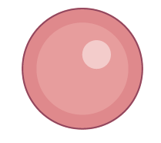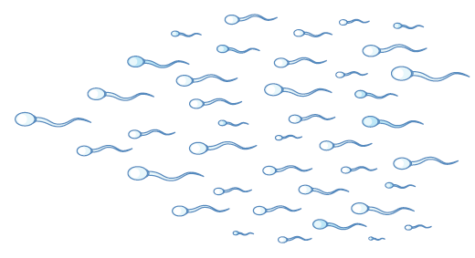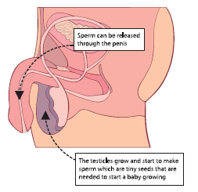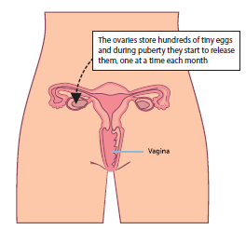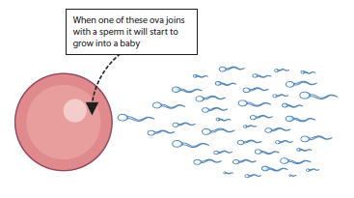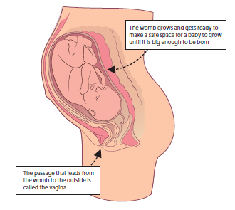  Y5 resources:  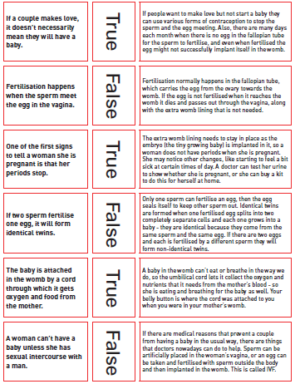
 | Changing Me - Physical attraction (boyfriends/ girlfriends)/ Respect and consent/ Sexting  This is a combination of the Y4 ‘Girlfriends and boyfriends’ and the Y6 ‘Physical attraction (boyfriends/ girlfriends)/ Respect and consent/ Sexting’ lessons. |  | Su2 |  | What do we teach the children about boyfriends and girlfriends? What do we teach them about sexting? |  | First, we start by discussing the difference between having boy and girl friends and having boyfriends and girlfriends. We explain how sometimes boys and girls will start ‘going out’ with someone but that this can be at any age and only when the person is ready. We discuss certain pressures that people may feel to have a boyfriend or girlfriend and that this pressure of being in a romantic relationship can have positive and negative consequences. We discuss where these pressures may come from - TV, peers, social media etc. - and what we can do to not give into those pressures if we don’t feel ready and comfortable. We then go onto using scenarios about how people might ‘date’ but how that doesn’t mean that they should feel under pressure to be romantic.  We speak to the children about how pressure can come in many forms, from saying someone is your boyfriend or girlfriend to being asked to send photos in your underwear. We talk to the children about what sexting is, as well as the laws around creating/ sending images of people under 16, even if you take the photo of yourself. We discuss how once a photo is taken, even if you delete it, it can still be retrieved. We need children to understand the impact of sexting and empower them to say no if they don’t want to do something or know something is wrong. All of this is to make sure our children are safe and know who to go to if they ever feel under pressure.

