After School Child Care

Dear Parent and Carers
Thank you for your enquiry regarding our After School Care.
Please see below for a summary of some important points regarding this after school care:
- This club will run until 6pm Monday to Friday
- A light, healthy snack will be provided by the school
- Activities will be provided
- This provision is for Reception to Year 6
- Places will be allocated on a first-come, first-served basis
It is important that you collect your child on or before 6pm. Collections after this time will incur a penalty fee of £5 for every 15 minutes after 6pm. Repeated late collections will result in places being forfeited. You will be liable to pay for all days you have registered for, whether or not your child attends the club on the day.
To apply for a place in this club please complete the attached registration form fully and return it to the school office.
Once your place has been secured, you must give a full half-term’s payment to the school office in advance or the place will be forfeited.
If you have any questions, please do not hesitate to contact us.
Yours sincerely,
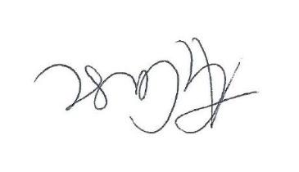
Anna Case
Headteacher
After School Child Care Application Form
Please complete the below fully and hand it to the school office
Prices
1 day per week | £8
2 days per week | £16
3 days per week | £24
4 days per week | £32
5 days per week | £40

Please complete one form per child.

Child’s Name: Class:

Parent Name: Contact Number:

Please circle the days required: Monday Tuesday Wednesday Thursday Friday
I understand that late collection will result in a penalty fee of £5 per 15 minutes and repeated late collection could result in my child’s place being forfeited. I understand that I am liable to pay for all days I have registered for, whether or not my child has attended.
Signature:

Name of surgery: | Telephone number:
Address:

Medical information: Does your child suffer from any of the following:

Eczema Allergies Hay fever Diabetes

Migraine Asthma Epilepsy Sight Problems

If you have selected any of the boxes, please inform us of any treatment given and/ or any extra information
__________________________________________________________
Is your child allergic to plasters? YES / NO
Dietary information:
Does your child have any food allergies? YES / NO
If yes, please give details___________________________________________________

Are there any restrictions on any particular food(s)? YES / NO
If yes, please give details _____________________________________

